Team 1:

Abbadi, Maha 2387279

Yapp, Leah Teresa 6284110

Li, Fei 6284258

Xie, Linlin 2343895

**Website Design Final Project**

1. Overall Goal – What is the primary message of this Web page? What is this organization trying to communicate?

The website’s primary goal is to promote and market a company who is offering wedding planning services. The organization is trying to show that the client can depend on them to give a good, organized wedding tailored to the client’s needs.

1. What is the purpose of the site? Why do you think this organization wants to share this information? What do they have to gain?

The site is mainly used as an advertisement for the company and to show the services that the company provides. Eventually, the goal is to become well known for their quality services and dependability. The company is a for profit company, so the more well known they are, the more income comes into the company.

1. Who is the intended audience? Will the audience consist of potential customers, current customers, or employees of a particular company or industry? Whom do you think this organization's message is directed to? Who would want to know this information? Do any of the following factors relate to your audience: age groups, social-economics, geography, gender, education, culture?

The intended audience are women who are engaged. They are going to be potential customers. Information is for the public. The audience would be female adults. Geography would mainly be in the Montreal or Quebec area since the company is in Montreal. For individuals who care about their budget for a wedding because it is cheaper having all resources come from one place rather than looking at individual companies and paying full prices for each.

1. What are the goals of the site? To advertise a company or organization, supply a service, or process orders?

The goal of the site is to advertise the company and the services they provide.

1. What do you want the website to deliver? What results do you want to see?

The results we want to see are more views on the website and more people using the company for their weddings. Ideally more clients make appointments with us and eventually use the company for their wedding.

1. What information do you need?

Information needed is content for the pages and images to show previous weddings the company have done. For appointments, we need the user’s personal information like their name, email, and phone number.

1. What opportunity, problem, or issue is your site addressing?

Our site is addressing an opportunity for a company to become well known and get income. A problem it addresses is that no other company provides all these resources all from one place. Most of the time, clients would have to contact individual places and pay full prices. Since all the resources are together, the prices charged to clients can be discounted.

1. List the working title of each page on your Web site.
2. Sweet Symphony Home
3. Sweet Symphony Gallery
4. About Sweet Symphony
5. Sweet Symphony Contact Us
6. Sweet Symphony Appointment Sent
7. Sweet Symphony Servies
8. Rentals
9. Catering
10. Wedding Planning
11. List where you will obtain the content (facts, text, graphics, sounds, and video) for the web pages you listed above.
12. Home – images from: <https://www.pexels.com>

text from: <http://luxedestinationweddings.com>

1. Gallery – images from:
   * <https://www.shawphotoco.com>
   * <https://www.brides.com/what-is-wedding-reception-7967897>
   * <https://www.weddingwire.ca/mansion-weddings/quebec/dorval>
   * <https://www.pinterest.com/>
   * <https://rochealphotography.com/how-to-pose-with-your-wedding-party-on-your-wedding-day/>
   * <https://thebestweddingdresses.com/7-most-important-bridal-makeup-tips.html>
   * <https://www.mandyandrandy.com/blog/palais-de-justice-de-montreal-wedding>
   * <https://alextranphotography.com/blog/persian-wedding-montreal-omni-hotel>
2. About Us - images from:

* <https://www.canva.com/>

1. Contact Us
   * <https://www.engagedandinspired.com/contact>
2. Services – images from:

* <https://blog.bridals.pk/ceremony-reception/these-pakistani-catering-companies-serve-the-best-wedding-buffet/>
* <https://bongoandb.com/5-important-tips-when-planning-your-wedding/>
* <https://www.pexels.com>

1. Rentals – images from:
   * <https://www.etsy.com/ca/>
   * <https://ca.shein.com/>
   * <https://www.bridalguide.com/>
   * <https://charmynow.com/6-easy-wedding-centerpiece-diy-on-a-budge-with-5-tips-you-need-to-learn-now/>
   * <https://allcargos.com/product/wedding-chiavari-chairs-rental/>
2. Catering – images from:

* <https://impressionscatering.com.au/entree-ideas-for-your-wedding/>
* <https://www.weddinglds.info/lds-reception-catering/wedding-reception-appetizers-and-hors-d%E2%80%99oeuvres/>
* <https://www.bostonmagazine.com/weddings/2018/09/26/save-on-alcohol/>
* <https://osf.com/catering/>
* <https://tastytablecatering.com/2023/04/14/tips-for-throwing-a-100-person-catered-wedding-with-tasty-table-catering/>
* <https://rusticweddingchic.com/wedding-menu-ideas-for-each-season>

1. Wedding Planning –

quotes from:

* + <https://shotkit.com/wedding-photography-quotes-captions/>
  + <https://www.socialtables.com/blog/event-planning/wedding-planning-quotes/>
  + <https://www.starterstory.com/wedding-videography-business-instagram-captions>
  + <https://www.myglamm.com/glammstudio/bridal-makeup-quotes>
  + <https://www.pinterest.com/>

images from:

* + - * <https://www.istockphoto.com/photos/makeup-artist-portrait>
      * <https://www.thumbtack.com/ga/douglasville/makeup-artists>
      * <https://www.mycism.com/2022/11/top-demand-trades-barbers-hair-stylists/>
      * <https://www.dreamstime.com/stock-photo-portrait-chefs-team-finishing-dessert-plates-kitchen-image68277605>
      * <https://www.sanctuaryderm.com/contents/about/the-team>
      * <https://shotkit.com/portrait-poses/>
      * <https://2mmheadshots.com/headshots/need-group-headshots-on-location-or-in-studio/>
      * <https://www.pixpa.com/blog/how-to-become-a-professional-photographer>
      * <https://www.doola.com/blog/side-hustles-for-photographers/>

Navigation Structure (img)

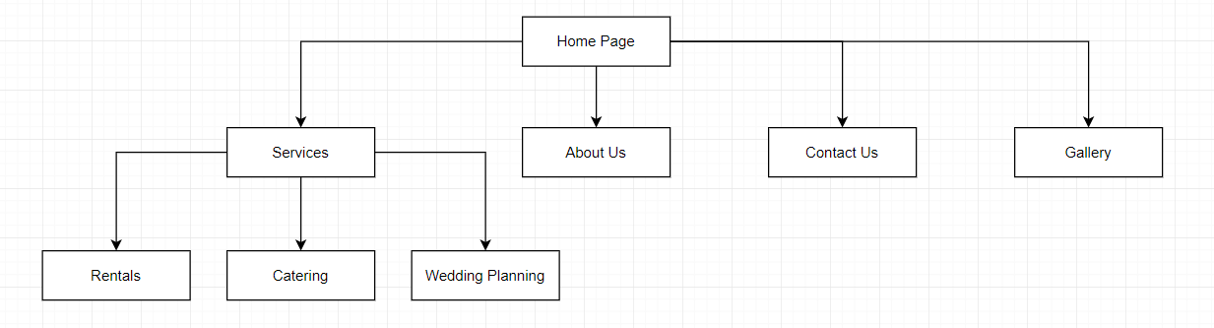

Mockups

Mobile View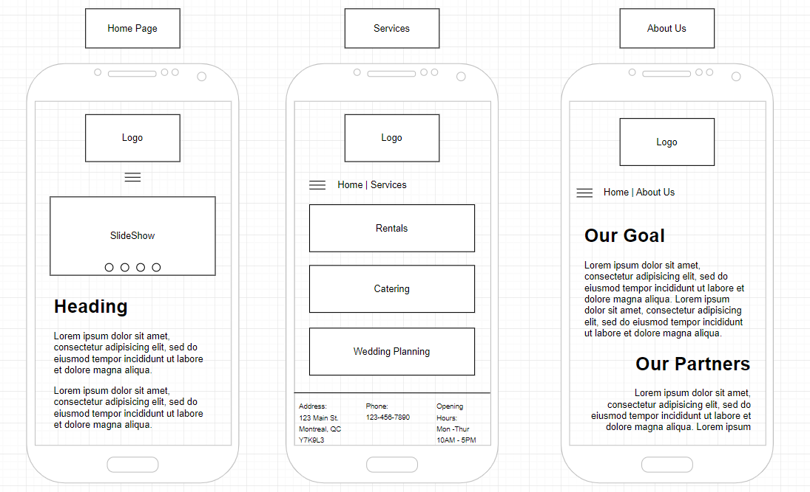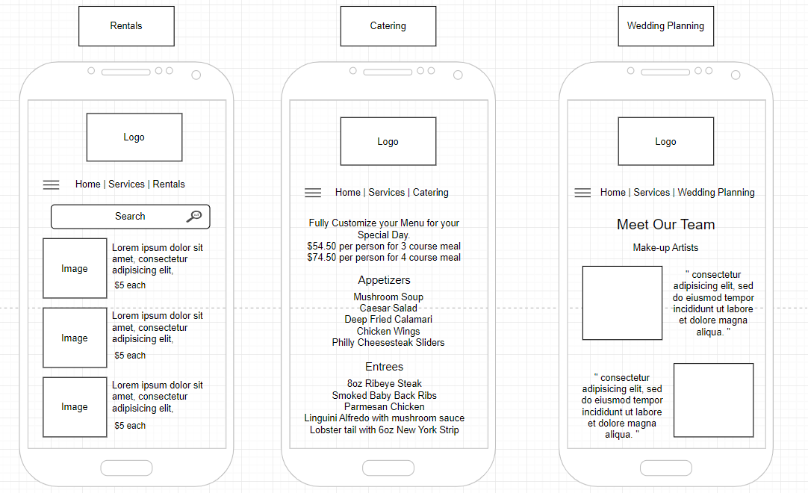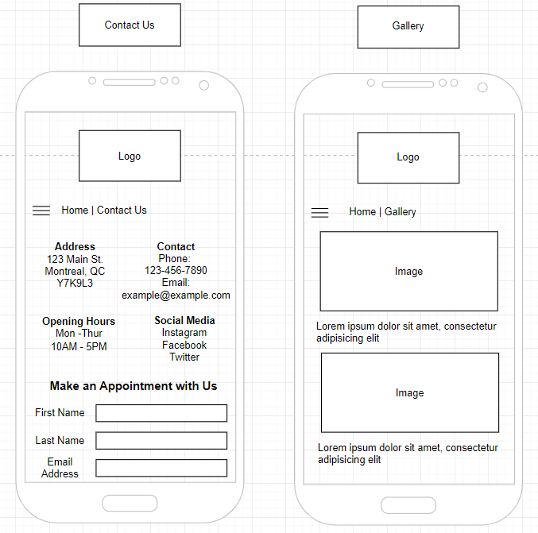

Tablet View

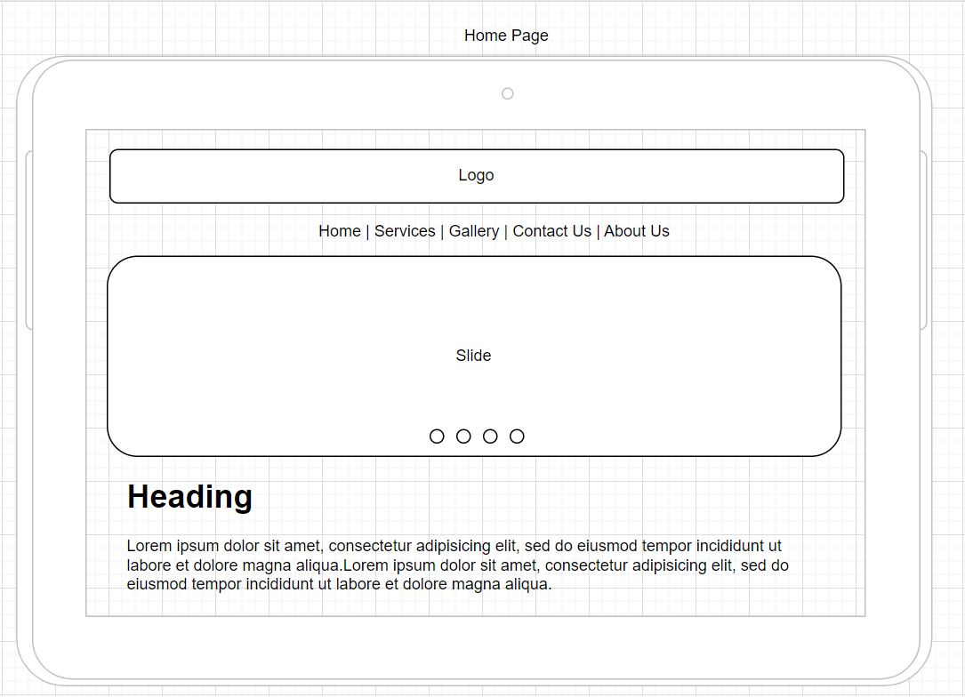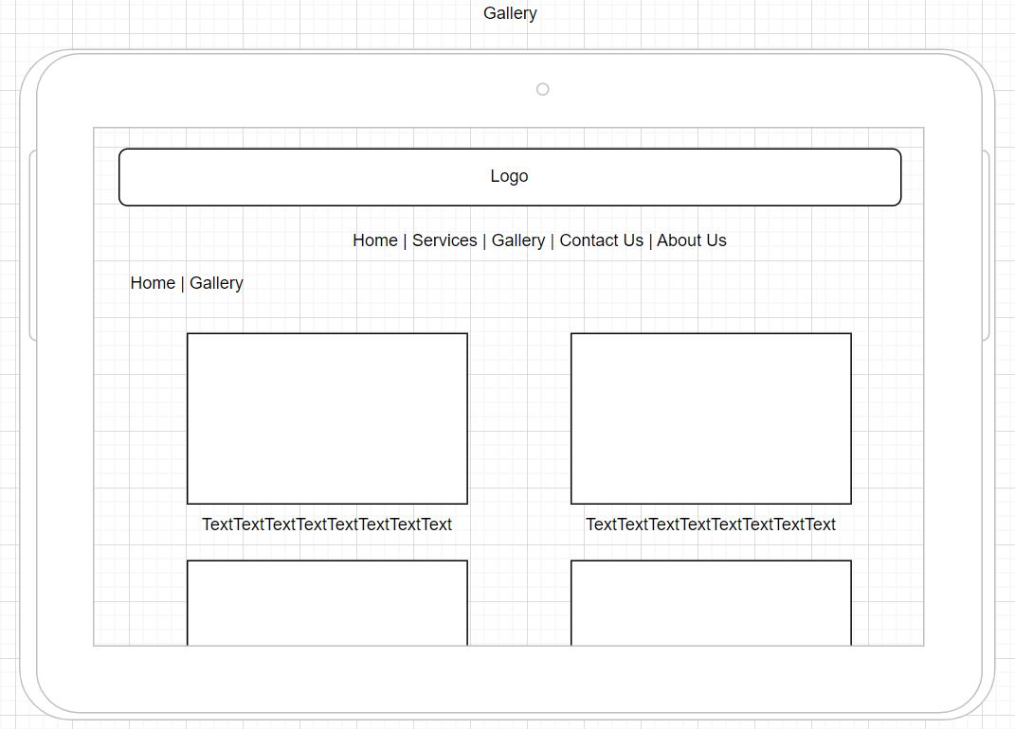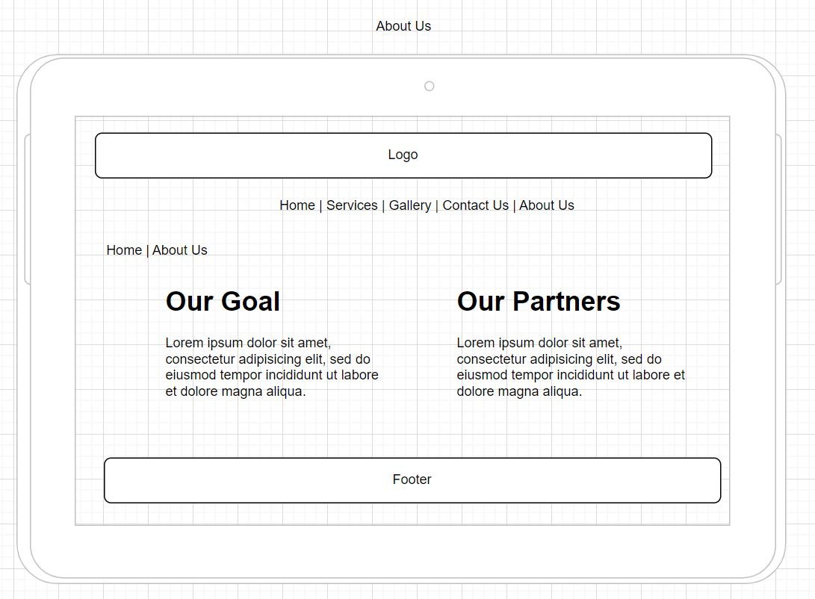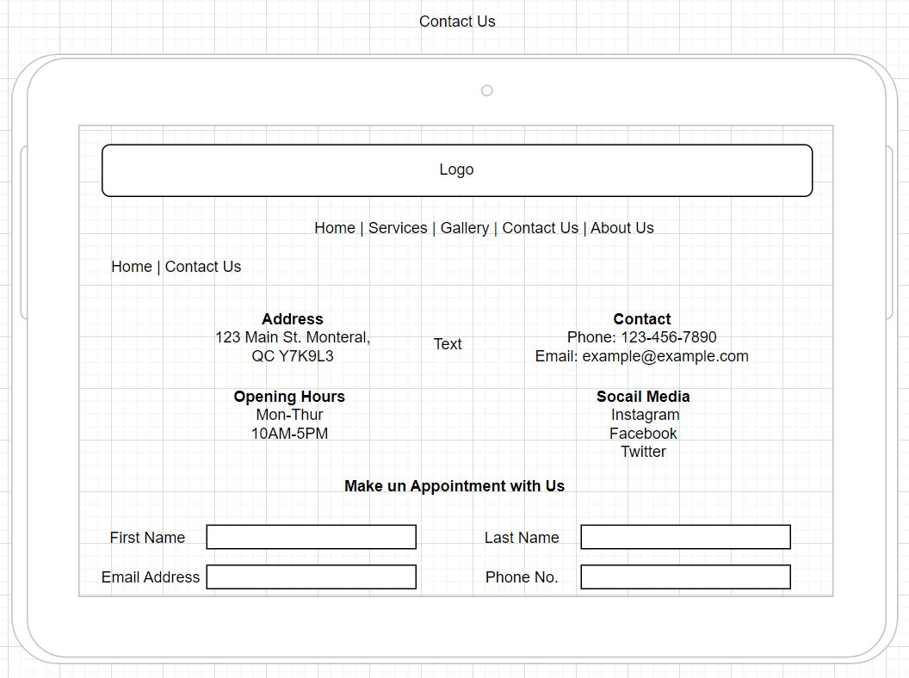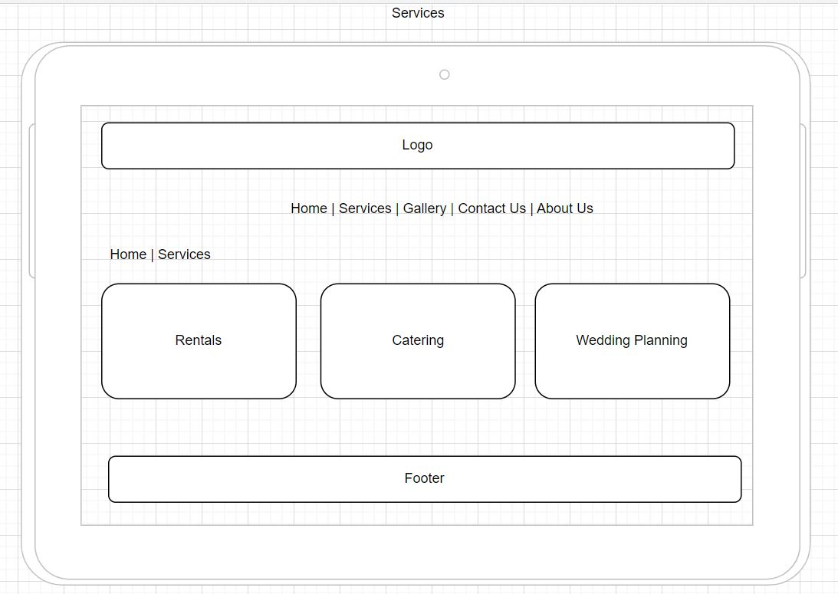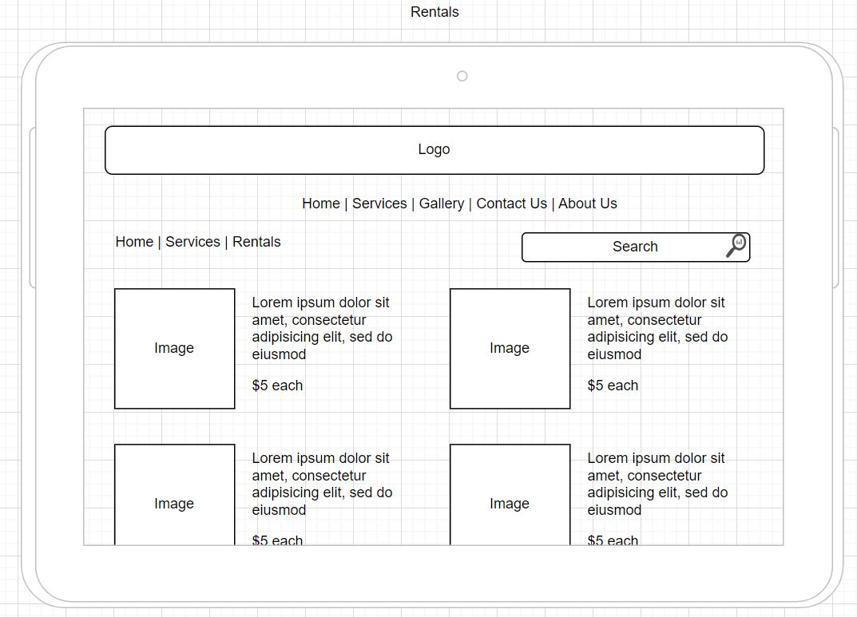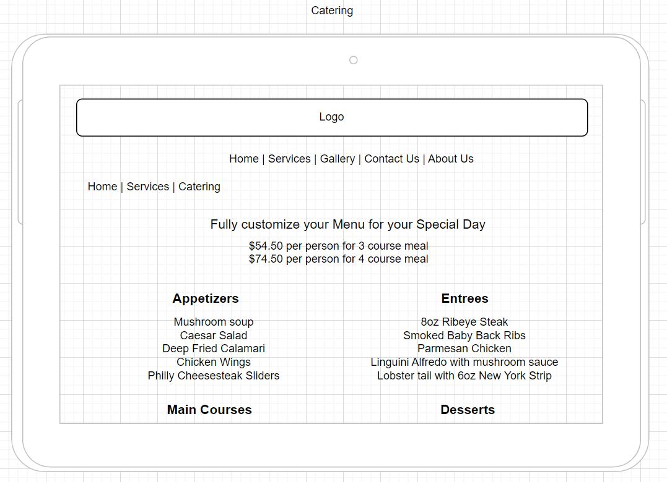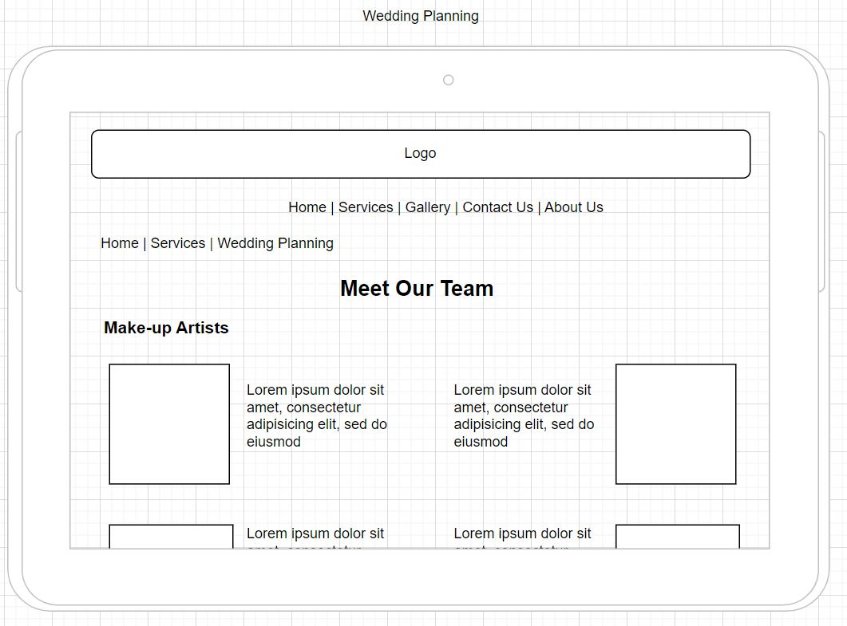

Desktop View

